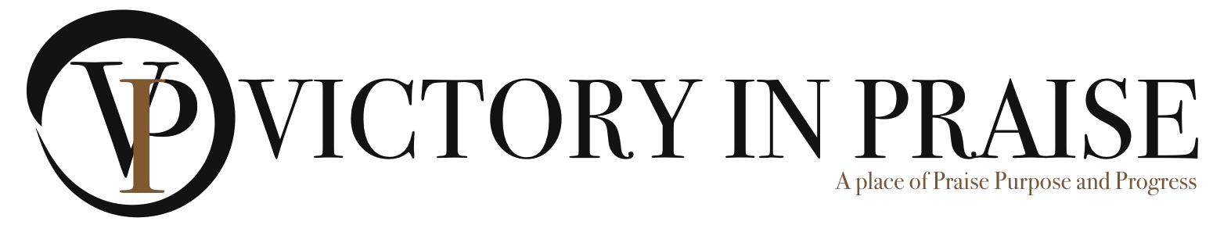

January 13, 2022
Greetings Friend,
Keeping the Arts alive and lifting the talent and skill of our youth…
Victory In Praise Board of Directors, in association with Care Free Praise Events cordially invite you to attend a “COMMUNITY EXPLOSION” Talent Show on Saturday, March 19, 2022, at 1:00 PM. This event will take place on the Victory In Praise campus, 2029 E. Harding Way, Stockton, CA. 95205. Vendor displays will be open for business at 11:30 AM, and the talent show will be held from 1:00 PM to 5:00 PM.
We are scouting out talent (ages 9 to 24 years), in churches, schools, colleges, and other community organizations, to showcase their abilities in the VIP Stockton Challenge. We want school bands, singers, dancers, spoken word poets and musicians, to foster a love for the Arts.
Come support and be “wow’d by our youth and young adults, as judges search for that special talented individual or group. Top winners, in each category, will receive a “First Place Blue Ribbon” and perform during the Juneteenth Festival on the Main Stage! (Juneteenth Saturday, June 18th, 2022, at the Weber Point Waterfront Park). Second and third place winners will receive ribbons and other fabulous prizes.
General admission tickets are $10 in advance; $15 at the door. There is no cost for the registered participants. Mail checks payable to, Victory In Praise to the address below or our website to purchase tickets https://www.eventbrite.com/o/victory-in-praise-church-15186521685
Bring your entire family and invite friends. There will be vendors, great food, and a live radio broadcast with Live I-5 and more.
Join us in supporting the youth and young adults in our community.

Warm Regards,
Terri Monroe
Event Coordinator
209-426-1110
www.victoryinpraise.org

